**S-Locker**

**The User Manual**

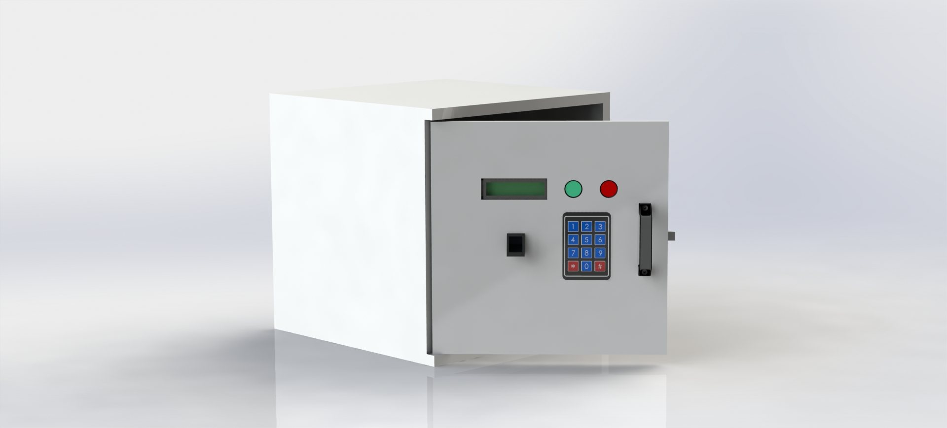

**Content**

1. Overview
2. How to use the system
3. User
4. Admin
5. Troubleshooting
6. Safety Precautions
7. Customer support
8. **Overview**

These days we have heard some cases of stolen bags and laptops of students inside the university premises. It happens mostly when students go to the library or laboratories. Because they are not allowed to enter those places with the bags, they have to leave them outside, and there must be more facilities to ensure their security. So as a solution, we will develop an intelligent locker system for those places.

Currently, there are some lockers to keep bags and other belongings in those places, but those lockers can’t provide more security. Our locker system will connect to the mobile application. Students can book a locker using the application, but the booking will be canceled unless the locker is occupied for two hours. To unlock a locker, students should select a locker number and open it using the mobile application, fingerprint system, or numerical keypad. After getting the bag, students must lock the vault. If the student has left something in the locker after leaving, they will get an alert from the app, and no one will be able to occupy the locker until they are removed. The system will also include a rechargeable battery as a power backup in case of a power cut.

1. **How to use the system**
2. **User**

First, you have to install the S-locker application using the given link.

App link: -

Step 1:- Creating an account

Open app

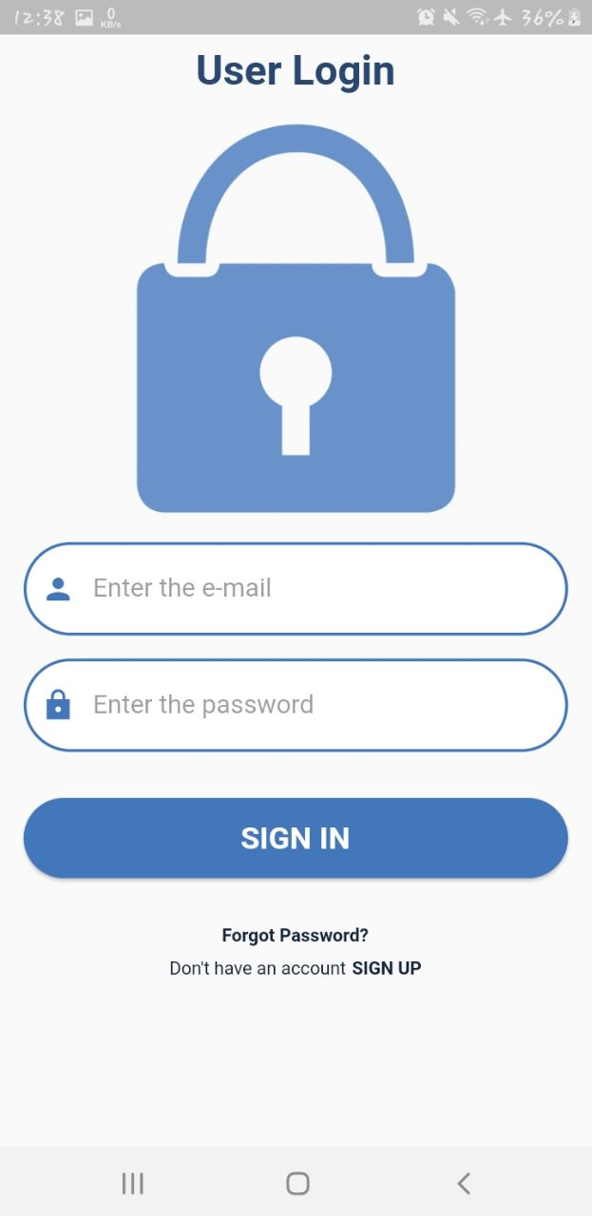

This will be the window once you. Open the app since you don’t have an account, and touch on signup. If you already have an account and the password was forgotten, touch on forgot password option.

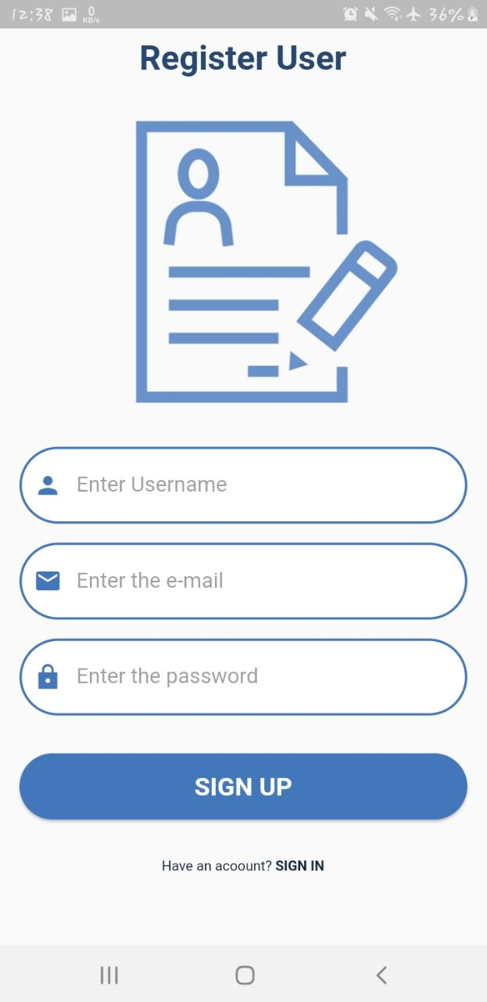

Once you click on signup, you have to fill in this field and create an account. Add a touch signup button.

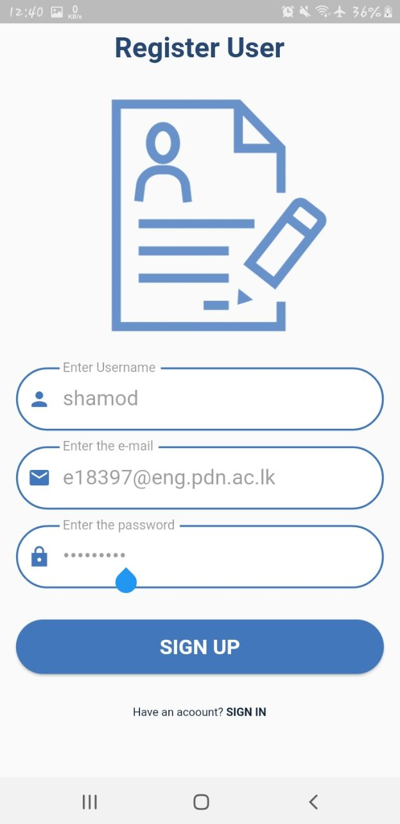

Then you can see following window.

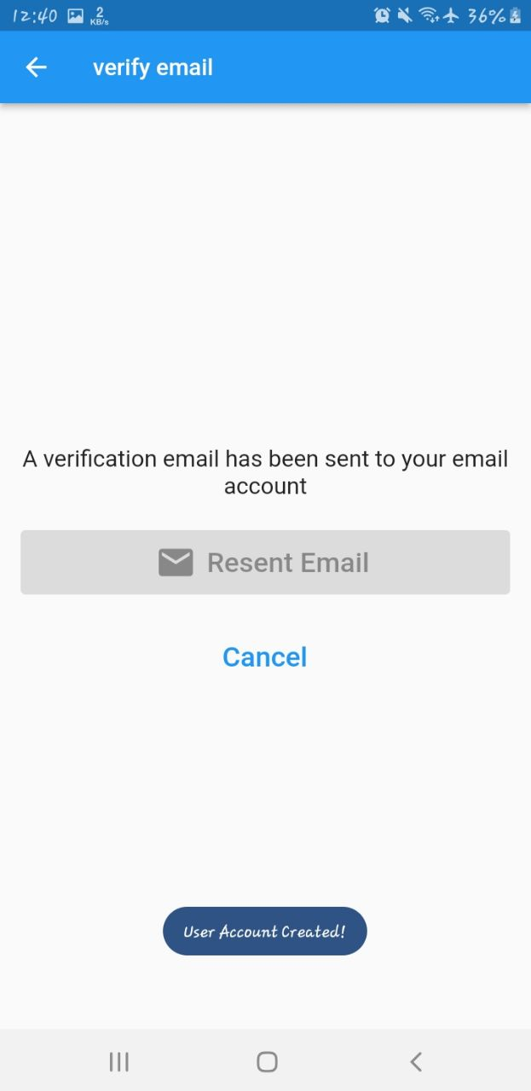

To access the account now, you have to go to your mail and check for emails. Check your spam folder if you can’t find the verification mail in your inbox.

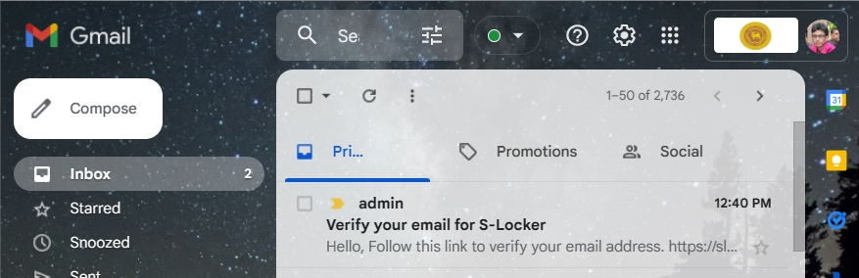

Go to the mail and click on the link.

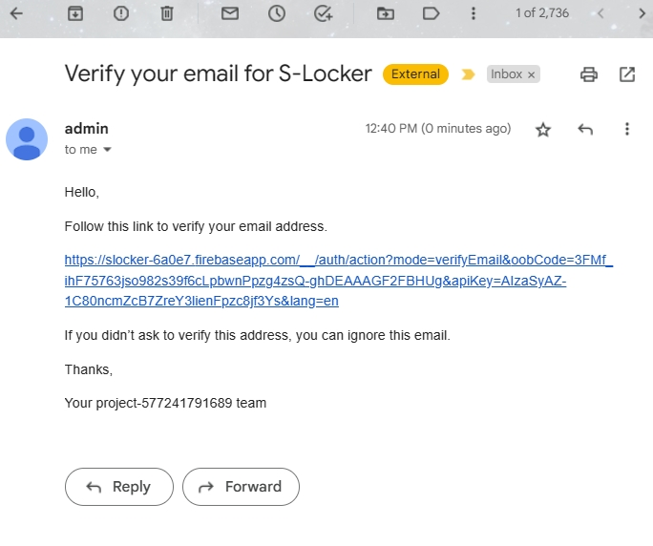

Once you click on the above link, it will redirect to the site and prompt a message that the email was verified.

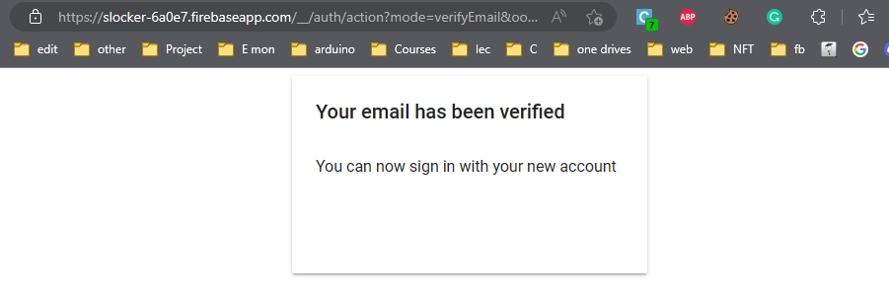

Once the email is verified application will automatically navigate to the home screen. Where you have control over lockers and reservations.

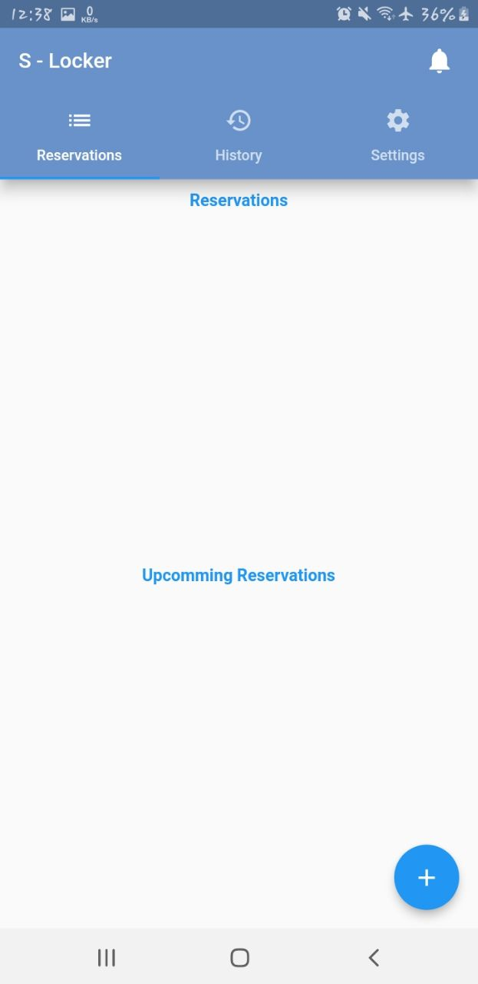

Using plus mark in the above screen. You can make reservations for your lockers.

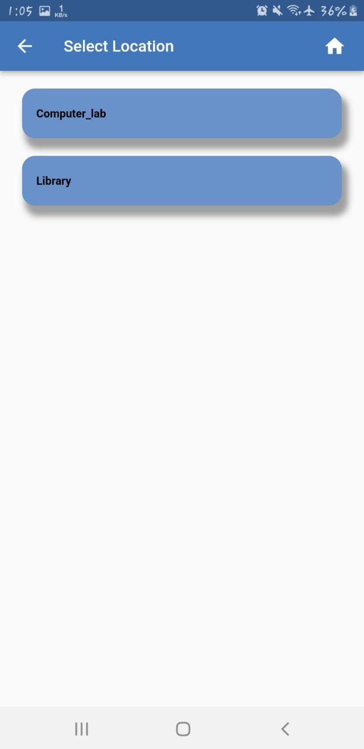

It will allow you to choose the location for your reservation. Once you select a location, you can choose a locker in the next window.

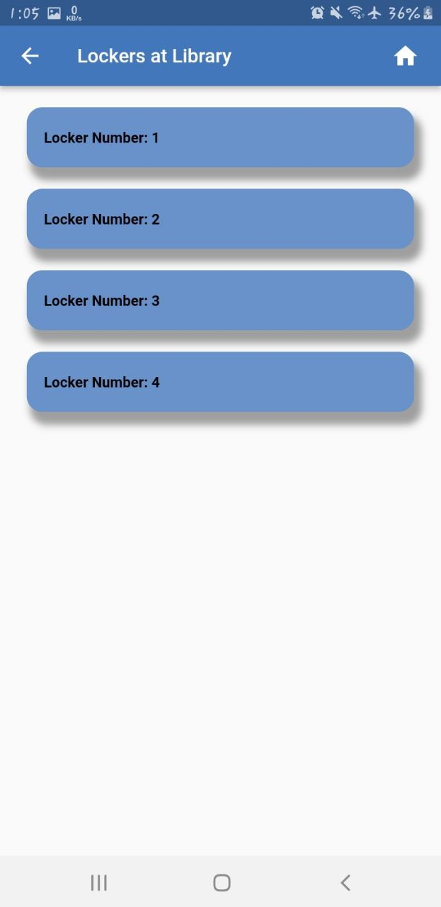

Touch on the locker which you are going to reserve. It will prompt a dialog box where you can insert a pin. Which should allow only 4 digits.

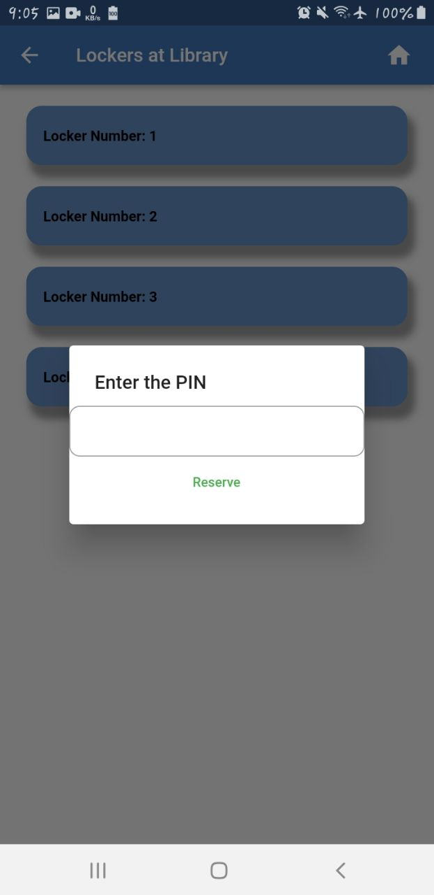

Once you click the reserve button, the reservation will appear on the upcoming reservations until you physically claim the locker. If you haven’t claimed it physically, the reservation will automatically be canceled within 120 minutes.

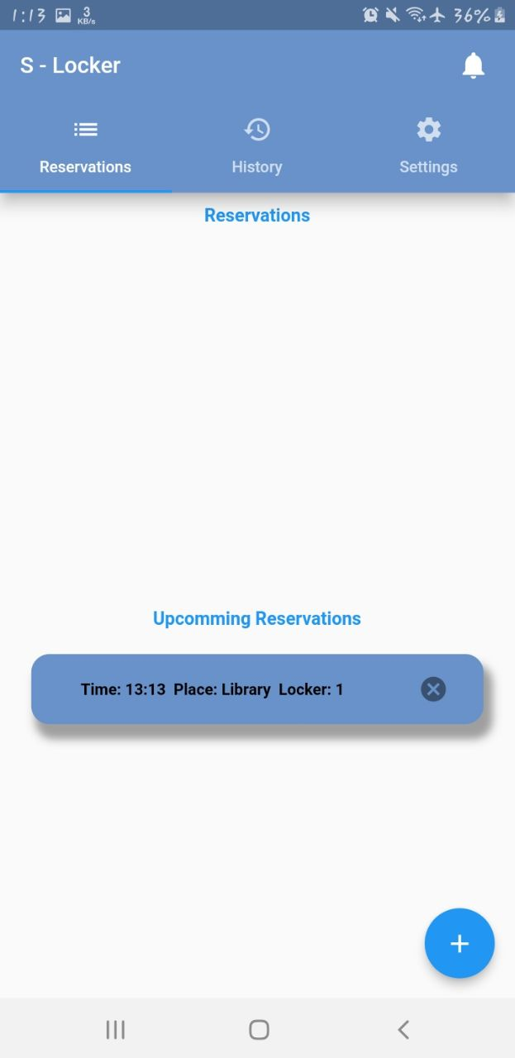

Once you create a reservation, If you don’t need it, you can cancel it at any time.

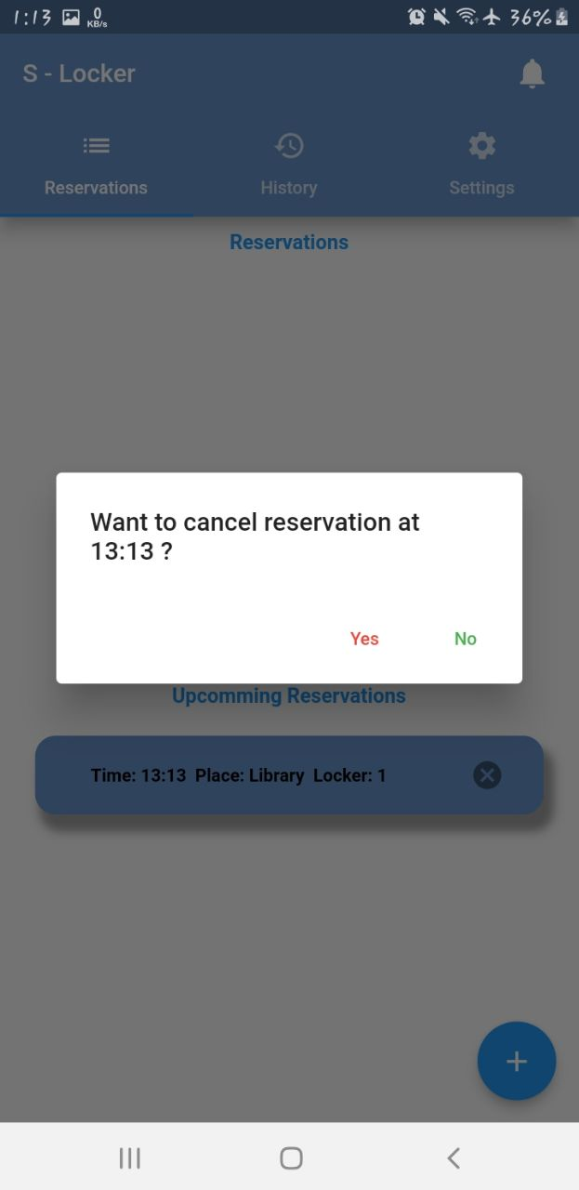

Once you physically claimed a locker. Reservation will go to the reservation state where you can have lock unlock features.

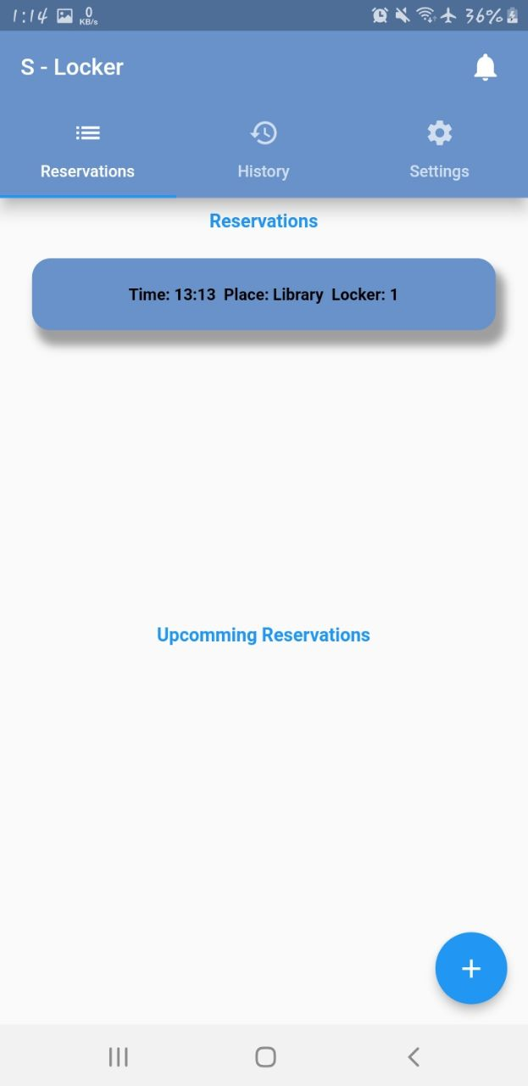 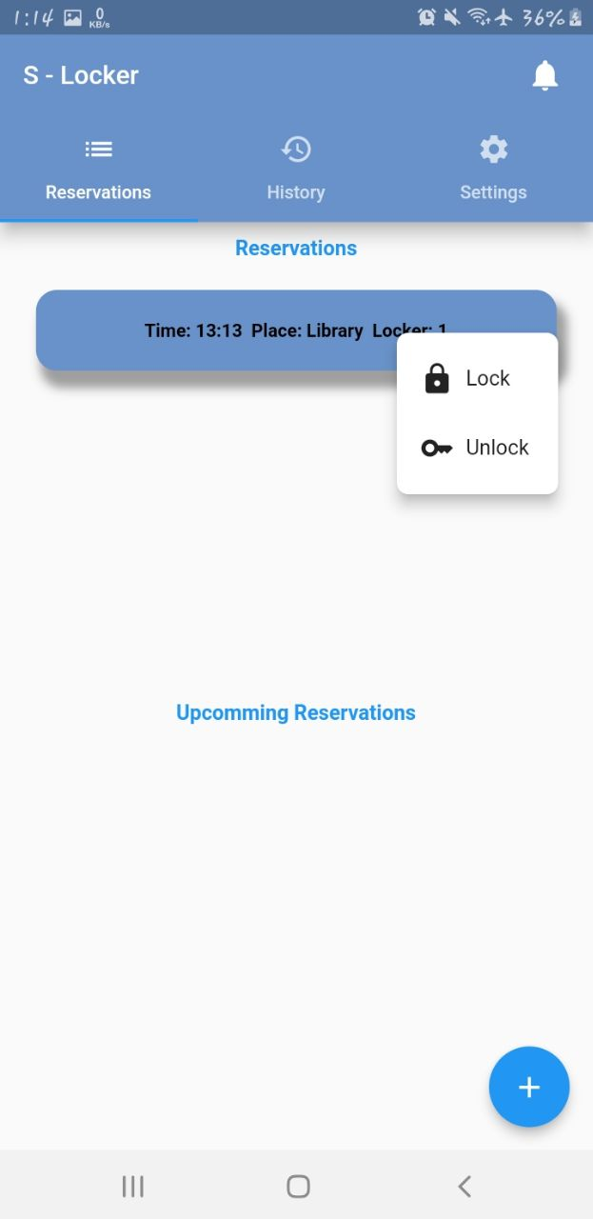

History view will have a record of your reservations.

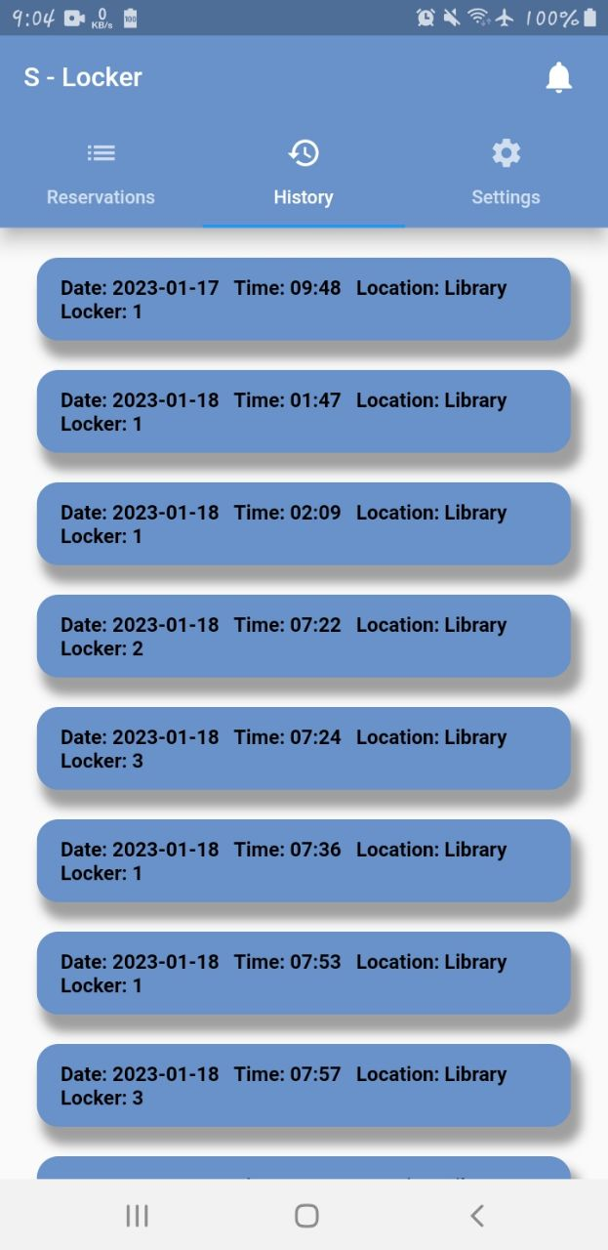

In the setting view you can change your account password and logout.

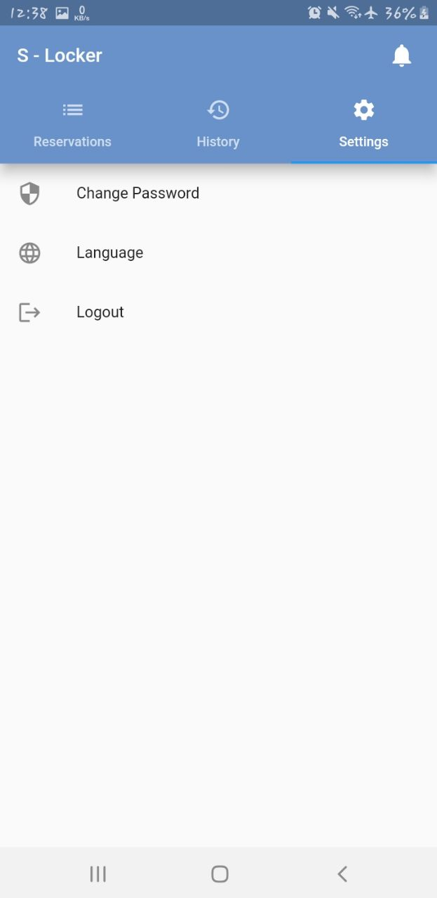

Claiming the locker physically

Suppose the locker hasn’t been reserved by anyone. Lcd display will show a welcome message.

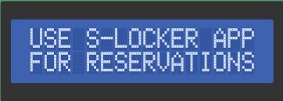

Once Someone reserved the locker, it will prompt to enter the pin;

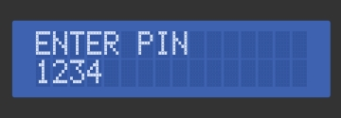

You can enter the pin using the keypad. While entering to clear the last character, you can use the * button and the whole clear pin; you can use the # button in the keypad.